**DEMO2002 W5 Tutorial**

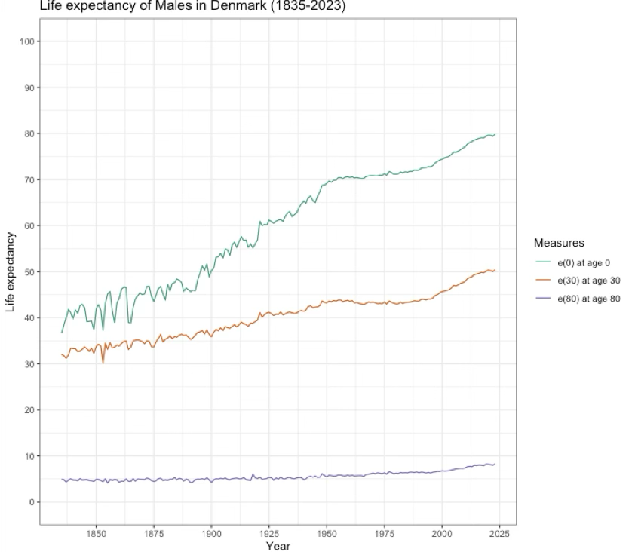

The above figure depicts the evolution of life expectancy at different age milestones based on period data of males in Denmark. We observe life expectancy for people to survived to age 0, age 30, and age 80 between the years 1835-2023.

For all age milestones, we see a general increase in life expectancy from 1850-1950.

The steepest increase in life expectancy is observed at age 0, pre-1950, before slightly tapering off. The plot implies that health advancements during this period aided both e(0) and e(30), but had more dramatically enhanced survival in the former. Indeed, the expansion of health providers and disease eradication during this time particularly reduced infant and children mortality (Kinsella, 1992). Virtually all industrialised countries experienced significant declines in mortality from 1900, with certain countries — like Denmark — having stagnation in male life expectancy from the 1950s-1970s (Kinsella, 1992). Afterwards, life expectancy resumed growth from the 1990s. In the post-WW2 era, the Nordic countries exhibited excellent trends in terms of improved healthcare and living standards; however other countries would soon catch up and occasionally exceed Nordic life expectancies (Knudsen *et al.*, 2019). Denmark has been criticized for their lax tobacco and alcohol protection strategies; research has related Denmark’s poor public health to higher usage and accessibility to these vices, for which there is “untapped potential” regarding control policies (Jarlstrup *et al.*, 2018). At age 80, life expectancy remains roughly stable with marginal improvement across the entirety of 1835-2023 — Denmark males can expect to live ~3 years longer had they reached 80 years of age in 2023 than 1850.

**References**

Jarlstrup, N.S. *et al.* (2018) ‘International Approaches to Tobacco Use Cessation Programs and Policy in Adolescents and Young Adults: Denmark’, *Current Addiction Reports*, 5(1), pp. 42–53. Available at: https://doi.org/10.1007/s40429-018-0187-x.

Kinsella, K. (1992) ‘Changes in life expectancy 1900–1990’, *The American Journal of Clinical Nutrition*, 55(6), pp. 1196S-1202S. Available at: https://doi.org/10.1093/ajcn/55.6.1196S.

Knudsen, A.K. *et al.* (2019) ‘Life expectancy and disease burden in the Nordic countries: results from the Global Burden of Diseases, Injuries, and Risk Factors Study 2017’, *The Lancet Public Health*, 4(12), pp. e658–e669. Available at: https://doi.org/10.1016/S2468-2667(19)30224-5.